The Profit Motive:
Encouraging Bank and MFI Lending to Farmers and Agri-Businesses

Gary Reusche, Thon Huijser, Myles Watts, and Pavlo Kostromytskyi
Abstract
Development programs that encourage bank lending of small amounts to agribusinesses or primary producers have had limited success, though various non-market mechanisms have been employed to provide incentives for banks to lend to this sector. This paper argues that, in order to be successful, these programs must focus on providing a competitive rate of return to bank equity. A simplified cost/benefit model for lending to agricultural clients is presented, calculating a minimum profitable loan size and demonstrating how reducing bank costs without increasing the probability of default should substantially increase small loan lending. This paper dramatically displays the non-viability of smaller loans under the usual lending approaches and discusses other agri-finance loan support mechanisms, including the ability of aggregate farm groups to increase loan size and the importance of crop insurance.

Table of Contents

- Introduction 1
- Motivation to Lend 1
- Minimum Profitable Loan Size 1
- Parametric Lending 2
- Risk Assessment 2
- Agricultural Insurance 2
- Aggregate Lending 3
- Conclusion 3
- References 4
- Annex A. Model outcome 5
- Annex B. Excel input template for the model set-up 6
- Annex C: Model methodology and definitions 7

- Introduction

In this era of growing food insecurity, every effort must be made to encourage agricultural development by placing financing into the hands of small-scale farmers and agribusinesses. For this sector, IFC has two lending streams: direct, and through financial institutions. Direct lending is typically inappropriate for small and medium-sized operations of less than $1 million. Therefore, the best way for IFC to finance agribusiness and producers is to lend to banks and microfinance institutions, which will in turn lend to agribusiness clients.

However, bank development programs that encourage lending to this group of producers and agribusinesses have thus far had limited success. Various strategies have been attempted, including government mandated percentages of the loan portfolio, specialized state-owned banks, interest-rate subsidies, and risk sharing mechanisms, to little avail (1). The popular view is that lending to primary production is very risky.

Yet banks with adequate risk assessment instruments have lent to this sector successfully and profitably. Further, non-performing loans (NPLs) in this sector are no higher than in other sectors—and often lower (2). Thus, improving financial markets that lend to agribusiness is a business opportunity for the bank, not simply a social or government response to food shortages and rural poverty. Bank lending to agribusinesses is no more risky than other forms of lending as long as the bank has the proper systems in place, adequate understanding of the sector and strong risk management tools.

IFC programs should use several key mechanisms to decrease risk, increase profit potential, and encourage financial institutions to provide loans to agribusinesses and farmers.

- Motivation to Lend

Financial institutions are motivated by profit. In deciding whether to make a loan, agents focus primarily on returns – on the likelihood of that loan generating a profit that meets shareholder standards. Banks prefer to lend to large businesses and producers, which are less risky and generate considerable returns. MFIs, meanwhile, do make smaller loans. But they must be encouraged to provide agricultural loans because their financial plans generally require monthly loan payments and most farmers are able to make payments only after harvest.

Past failures and current constraints to agribusiness lending can be better understood when viewed from the perspective of the bank. Yet once loan agents learn that small loans to agribusinesses and producers can make a profit, they are likely to embrace them, disregarding previous assumptions about loan size. To this end, the model below uses a cost-benefit analysis to determine banks’ minimum profitable loan size, providing loan agents a threshold.

- Minimum Profitable Loan Size

This simplified model is based on a return on equity (ROE) of 15 percent as the lowest possible return threshold for bank shareholders. This means that loans estimated to generate less than 15 percent returns would be seen as unwise and refused; loans above that threshold would be a good business decision that meets investor standards. Therefore, program goals to increase agribusiness lending will be supported by bank shareholders only when this threshold is met.

The model inputs the bank costs and benefits related to agricultural lending, and calculates the minimum average loan size that would meet corporate goals for investor returns. [Note: the parameters and assumptions of the model can be adjusted to reflect the terms and conditions for a specific country and/or bank. See Annex C.]

Based on simple assumptions regarding personnel and other costs, including risk, the model finds that a loan of $25,000 can be profitable (Annex A). With loans under $20,000, the interest rate (for the lending institution, the interest rate margin) increases rapidly. Alternately, with loans greater than $30,000, the interest rate remains flat. Thus, $25,000 is the low-end threshold at which banks can expect to generate 15 percent ROE.

- Parametric Lending

For smaller loans, the use of parametric methods to assess clients is essential. In order to make small loans profitable, loan-processing time must be reduced. A good way to do that is via parametric statistical assessment of loan clients, which significantly reduces the number considered for loans. The introduction of parametric lending can cut loan-processing time by several days in some regions, reducing minimum profitable loan size by up to 60 percent (See Annex C). World Bank research has confirmed that banks that lend to producers in different markets adopt parametric client assessments. These rapid assessment techniques help ensure the loans are profitable (3).

- Risk Assessment

With every loan there is a risk that a client will fail to make timely repayments. Such failures put a loan in default, making it a non-performing loan (NPL). The cost of risk, or loan loss cost, is the total amount the client fails to repay. Lending institutions assess credit risk prior to disbursing a loan, thoroughly considering the client’s probability of default. IFC projects in Tajikistan and Ukraine undertake research to develop cash flow models and benchmarks that banks can use in their lending practices. Such instruments are designed to increase the accuracy and effectiveness of the client assessment.

After disbursement, banks monitor client performance and the potential adverse impact of market developments to further limit the cost of risk. In developing countries, political and judicial risk can contribute to the rate of default and must be closely watched (See Annex C). Good credit risk assessment practices help reduce the probability of default, but ultimately the success of risk management is directly related to the time spent on loan analysis.

- Agricultural Insurance

A key risk management tool is agricultural insurance. If a farmer expects to grow 100 tons of produce in a given year but grows only half that due to drought, he is likely to default on loan payments. Insuring crops against such weather events helps farms reliably meet their loan requirements.

If the farmer has crop insurance, bad weather triggers an indemnity payment from the insurance company to the bank to cover loan payments. The bank has a fresh source of cash to repay the facility, so its net loss, if there is any, will be substantially lower. In fact, the indemnity payment is often pledged to the bank as part of the loan agreement. Even during sub-optimal years, crop insurance significantly reduces the probability of default. In the end, agricultural insurance is appealing to banks because it significantly lowers risk.

- Aggregate Lending

Risk can be further reduced by lending to agricultural aggregators. In many regions, small agribusinesses and producers link-up to form a collective legal entity known as an agricultural aggregator. By taking over some assessment processes and spreading repayment responsibility across many producers, these groups reduce costs and ameliorate risk for the bank, which views the aggregated group as a single client to which it can provide larger loans. From the bank perspective, the aggregator is the loan client and the object of due diligence. Joining forces to form a larger legal entity, small-scale farmers and agribusiness become more attractive to banks – but they must ensure proper administration of the group.

- Conclusion

Efforts to increase bank and MFI lending to agricultural producers will only be successful if the challenge is approached from the perspective of the financial institutions, which view profit making as their raison d’etre. A bank will only make loans that it expects to generate a significant return on investment.

Banks with significant agricultural lending experienced have demonstrated that, when risks are properly assessed and managed, lending to small agribusinesses and primary producers (and agricultural aggregators) can be profitable and stable.
- References

- IFC. 2011. Scaling Up Access to Finance for Agricultural SMEs Policy Review and Recommendations.
- Unpublished IFC research. 2011. In 2011, Ukraine’s share of agri-lending was 4% of total volume of bank lending, the 7th largest sector. NPL share in agri-lending was 6.1%, versus 9.2% average for bank lending.
- Ajai Nair, parametric lending research.
- Annex A. Model outcome
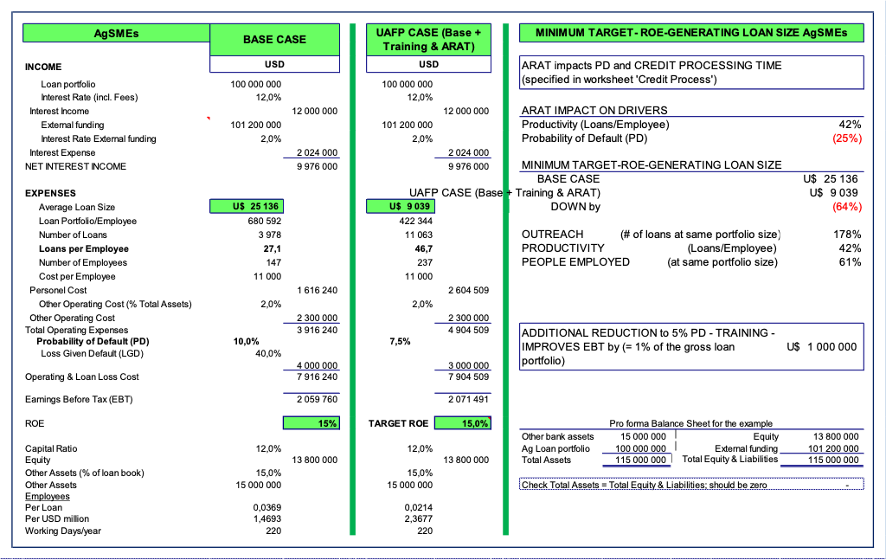

PLEASE NOTE:

The calculated minimum loan size is found by entering the parameters into the model, and using the excel function Goal Seek. This function: identifies the target ROE cell; enters the target ROE (percentage expressed as a decimal figure); and identifies the “average loan size cell.”
- Annex B. Excel input template for the model set-up

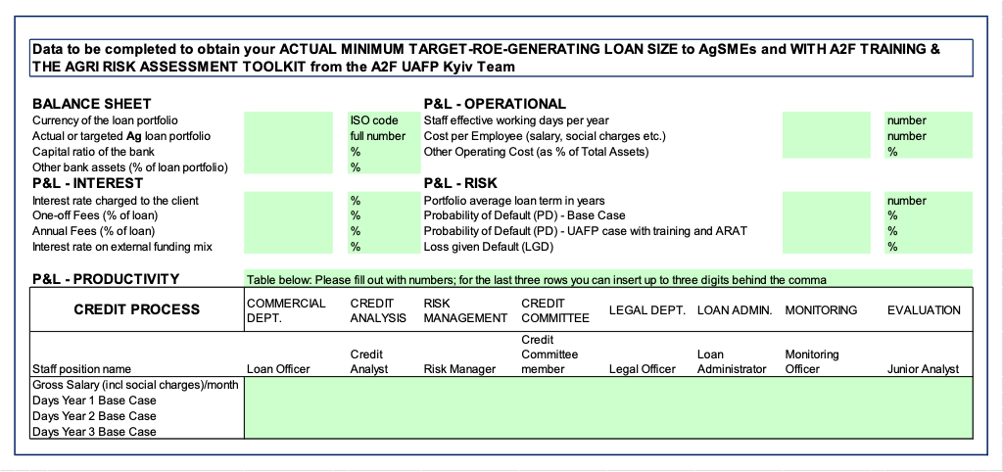

- Annex C: Model methodology and definitions

The model inputs the bank costs and benefits related to agricultural lending and calculate the minimum average loan that would meet the corporate goal to generate investor returns of at least 15 percent. Based on our assumptions, the minimum profitable loan size is approximately $25,000. (Note: Parameters may vary, and the parameters/assumptions of the model can be adjusted to reflect the terms and conditions for a specific country and/or bank.)

The model defines interest on a client loan as follows:

Interest on a client loan = Cost of funds + Operational cost + Cost of risk + Profit (Return)

The Profit or Return is used to calculate the ROE (Profit/Equity). Bank shareholders and boards have a threshold ROE strategy to achieve business goals (Target ROE). The minimum level of equity a bank needs to retain against each loan is set by the Bank for International Settlements, and broadly depends on the risk quality.

Profit (Return) = Interest on a client loan – Cost of funds – Operational costs – Cost of risk

Client interest rate and cost of funds are dictated by the market. Cost of funds is the interest a bank needs to pay to attract external funding (e.g., deposits from savers, loans from other banks or its central bank). Operational costs and the cost of risk are the two main factors influenced by the bank itself. IFC advisory services can focus on these issues to increase productivity, reduce risk, and grow a profitable agricultural portfolio.

Operational Costs are all costs related to due diligence, supervision and monitoring of the agricultural loan. In the model it is simplified to:

Operational costs = Personnel cost + Other operating costs

Other operating costs (such as IT-costs, overheads, utilities, PR, etc.) are assumed to be a percentage of the Total assets for simplicity.

The Personnel cost is calculated on the basis of time spent by the bank officers throughout the credit process chain:

Personnel cost = ∑ Officer Time spent on credit processing × Salary rate

Productivity is a key factor to personnel cost. It is measured by the sum of time required to complete a full credit process and monitoring cycle for a typical 3-year loan product by each bank officer involved. In a typical bank, loan officers, credit analysts, risk managers, members of the credit committee, and officers in the legal and loan administration departments are involved. After disbursal, monitoring and evaluation of the loan is undertaken. Table 1 (next page) is an example of assumptions for the total number of man-days per year of the entire 3-year cycle.

Table 1: Credit Process: Time (in days) by departments
Year | Sales | Credit Analysis | Risk Management | Credit Committee | Legal Dept. | Loan Admin | Monitoring & Evaluation | Total
1 | 4.0 | 5.0 | 0.50 | 1.25 | 1.5 | 1.5 | 0 | 13.8
2 | 2.0 | 0 | 0.25 | 0.375 | 0 | 0.5 | 3.5 | 6.6
3 | 1.0 | 0 | 0.25 | 0.25 | 0 | 0.25 | 2.25 | 4.0
Total | 7.0 | 5.0 | 1.0 | 1.9 | 1.5 | 2.3 | 5.8 | 24.4

Following from the model’s assumptions, operational costs per loan unit can be reduced by increasing productivity. The ways to achieve that are discussed below.

Cost of risk or loan loss cost equals the amount that is not repaid by the client to the bank, and the client is in default. When a loan is in default, it is classified as non-performing loan (NPL). All credit risk assessment undertaken prior to disbursement aims to minimize the cost of risk. After disbursement, monitoring the client performance and potential adverse impact of market developments in the sector in which the client is active also aim to limit the cost of risk.

Cost of Risk = Loan portfolio × Probability of Default × Loss Given Default

The probability of default, PD, is the chance of a default over a certain time period. The loss given default, LGD, is the average share of loss over the total exposure in case a client defaults.

Good credit risk assessment practices help reduce the PD. Good collateral, credit documentation, and a legal environment that allows for efficient enforcing of collateral will reduce the LGD. The PD and personnel costs are often negatively correlated. Better risk management is directly related to spending more time on the loan analysis. Effective and automated risk assessment instruments decrease the latter without increasing the former.

In developing countries political and judicial risk also contribute to either lack of loan repayment or increase bank costs. These can occur from a variety of sources such as a lack of ability to obtain collateral if a loan is defaulted or even the ability to collateralize a loan. Other possible sources include lack of contract law or lack of the ability to enforce contracts. Political actions may occur that increase banking costs such as excess reporting or pressure to support special politically popular initiatives. These considerations also raise the interest rate charged. These risk factors usually account for somewhere between 2 and 5%. To keep the model simplified, its impact is included in the LGD.

Based on the assumptions for the cost of money and staff salaries, a minimum loan size of approximately USD $25,000 is calculated by the model (Annex A). Assumptions may be different for each bank and country. Readers wishing to develop a model for a specific bank can use an Excel template to enter the necessary assumptions based on the specific bank of interest (Annex B).

Figure 1. ROE Isocline Chart
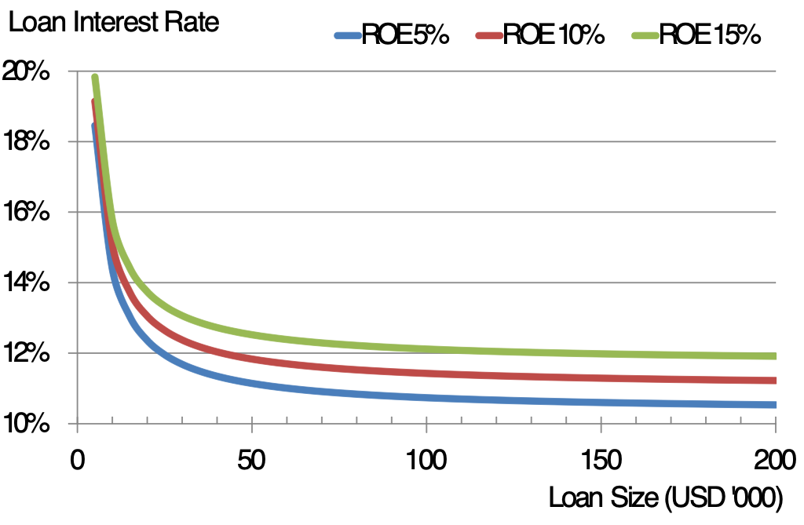

An ROE Isocline Chart (Figure 1) illustrates the relationship between interest rate and loan size. At loans under $20,000, the interest rate (for the bank this is the interest rate margin) increases rapidly to very high levels. This increase in interest rates for small loan sizes impacts banks and MFIs alike. Alternately, with loans greater than $30,000, the interest rate for the target ROE remains flat.

Parametric lending: Opportunities to decrease loan processing time will impact directly on the minimum loan size, assuming that the processes adequately control portfolio risk and keep NPLs low. For smaller loans, the use of parametric methodology to assess clients and reduce loan-processing time is essential. Using the same assumptions for cost, the amount of time to process the loan was investigated. The assumptions were adjusted to reflect anticipated productivity gains, thus reducing the overall processing and monitoring time during a 3-year cycle from approximately 24 to 14 days (Annex A). Consequently, the minimum profitable loan size decreased to approximately $9,500, a reduction of nearly 60 percent.

Simulations

The loan size model is useful to simulate the financial impact of decisions made by bank management, and to illustrate the potential impact of credit risk. Table 2 illustrates the impact of increasing NPLs on the minimum profitable loan size. The lower the percentage of NPLs, the smaller the loan a bank can make and still generate a profit. Alternatively, if a bank has a high percentage of NPLs, profit requirements will force it to move to larger loans. Table 2 also illustrates the impact of risk management tools that increase productivity.

Table 2. The impact of NPLs on minimum profitable loan sizes.
% NPLs | Min. profitable loan size- Standard (U$) | Min. profitable loan size- with risk management tools (U$) | Difference (U$) | Difference (%)
2% | 9,065 | 5,031 | 4,034 | 44%
4% | 10,898 | 5,725 | 5,173 | 47%
6% | 13,585 | 6,631 | 6,954 | 51%
8% | 18,097 | 7,882 | 10,215 | 56%
10% | 27,076 | 9,672 | 17,404 | 64%

About the authors: Gary Reusche has a PhD in agricultural sciences and has been doing advisory services for agricultural development for 39 years; Thon Huijser is an agri-finance expert with horticultural and economics background, over 32 years of experience across Europe, Asia and Africa banking and advising family-type agri producers up to multi-national agribusiness conglomerates; Myles Watts has a PhD in agricultural economics, is an agricultural actuary, and is Vice Chairman of Board of the Federal Agricultural Mortgage Corporation (a federally chartered, publicly traded corporation that provides a secondary market for agricultural real estate and rural utility loans.) Pavlo Kostromytskyi is a researcher and analyst developing risk management instruments for agricultural lending in the Ukraine Agri Finance Development Project.

